Oculomotor Capture Experiment 1

As noted in the introduction, participants in oculomotor capture experiments have previously been reported to be unaware that their eyes are persistently misdirected towards irrelevant sudden onsets when the task is to look at a colour singleton (Theeuwes et al., 1998). This conclusion was based on subjective reports: the experimenter simply asked participants during debriefing if they were aware of their errors during the experiment. Here we sought to gather a more precise and immediate estimate of how aware participants are of their own erroneous saccades. Participants moved their eyes to the one orange circle amongst an array of red circles and reported the letter (a “C” or reversed “C”) inside that circle. On half of trials an additional circle was added to the display at the same time as the orange singleton was revealed. Participants were asked after each trial to report whether or not they made a single eye movement directly to the orange circle target. If participants are truly unaware of the occurrence of oculomotor capture, as the Theeuwes et al (1998) anecdotal reports suggest, then participants should identify the vast majority of the trials as “good”, even when the eyes were misdirected to the irrelevant onset.

## Methods

### Participants

Ten participants took place in this study. <Details>

### Stimuli and procedure

Stimuli consisted of six small coloured circles (radius 32 pixels) *** need these in degrees of visual angle *** evenly distributed around a larger circle centered on the fixation cross with radius 256pixels. After 1000ms, all but one of the circles changed colour. The target circle was defined as the circle that maintained the same colour. A forwards or backwards ‘*c*’ appeared inside the target circle. On half the trials, an additional distracter circle would appear in between two existing circles. See Figure 7 for an example. The target and distractor array was displayed for 800ms.

|  |  |
| --- | --- |
| Macintosh HD:Users:s09ac3:Documents:EyeMovementAwareness:AttentionalCapture:preview.png | Macintosh HD:Users:s09ac3:Documents:EyeMovementAwareness:AttentionalCapture:stimulus.png |

Figure 7: Example of stimuli for the oculomotor capture experiment

There were six potential target locations and six potential distracter locations, so with three replications, this gave 108 trials. We included an equal number of trials with no sudden onset distracter to give a total of 216 trials.

Before the experiment began, participants were told that we were interested in filtering out those trials in which they made eye movement errors. Therefore after each trial they would be asked if it was a “good trial”, and that they should only response “yes” if their eyes went from the center of the display directly to the orange circle target. During the experiment, after each trial the question “Was this a good trial?” was presented on the screen, and they responded by pressing a “y” (yes) or “n” (no) key. If the participant responded “yes”, then they were asked to decide if the target “*c*” was forwards or backwards.

## Results

All of the participants managed to successfully discriminate the target (C or reversed C) on at least 95% of the trials. Participants were far less accurate in identifying the trials in which they made a “good” eye movement. In order to analyse this, we collapse over all target and distracter conditions and categorise trials based on the total path length of the saccades made by the participant during the trial. Path length was normalised so that 1 unit represents the distance from the central fixation cross to the centre of the target. We then classed trials in which the total path length was between 1-*a* and 1+*a* as “good” (*a*=0.2 unit). Figure 8 shows the number of trials classified as “good” and “bad” for each participant, and within each of these categories the number of trials the participant responded “yes” (good) or “no” (bad). It is clear from this figure that many trials with eye movement errors were classified as “good” by participants, consistent with the general observations of Theeuwes et al (1998) that participants are unaware of their errors. However, the proportion of trials classified as “bad” was higher among “bad” than among “good trial”, suggesting some sensitivity to their errors. This general ambiguity highlights the utility of the classification accuracy approach described in the general methods section above, the results of which are reported next.

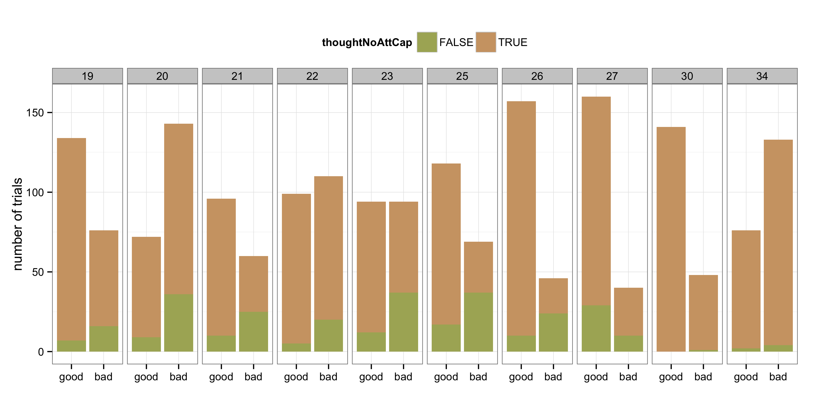

Figure 8: Results from the oculomotor capture experiment

From the classification accuracy scores (Figure 9) participants have reasonably good precision scores, that is, around 75% of trials that they reported as not good were indeed trials in which they made a saccadic error. However, median recall is much lower (25%). This tells us that participants are not sensitive to most of the saccadic errors they made during this experiment.

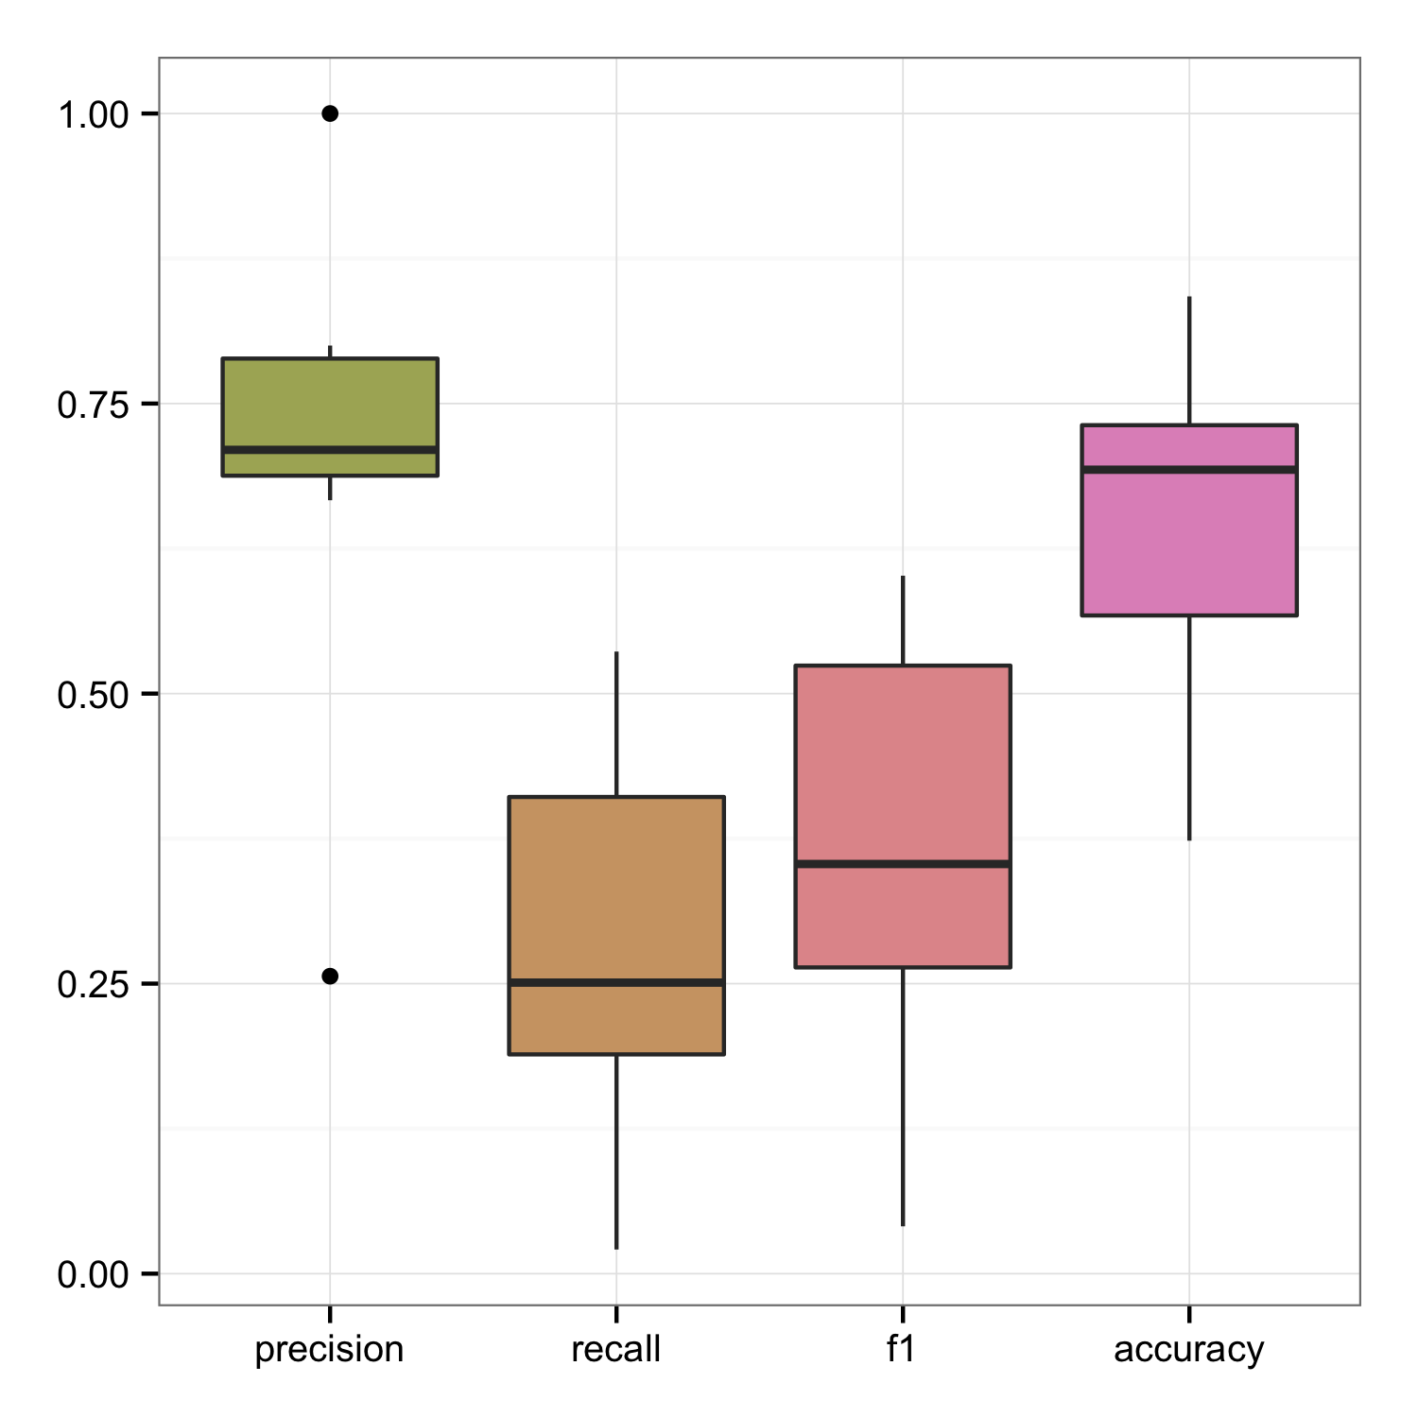

Figure 9: Classification accuracy scores.